Kingdom of Saudi Arabia  Ministry of Education  Eastern Province Education Department  Tarbeat Al-Ajial International Schools |  |  |  |  |  |  | Date: ……/………/..………  Subject: Computer  Grade: G7
……………… |  | Seat Number |  | ……………………………………….. |  |  |  | Student’s Name
Mid Term exam 2nd Semester 2026/2025
Sign. | Consultative Name |  | Sign. |  | Corrector’s Name | Marks in letters |  |  | Marks  in numbers
 |  |  |  |  |  |  |  |  | 20

Question A: write the correct name of each part.

Text | Video | Image

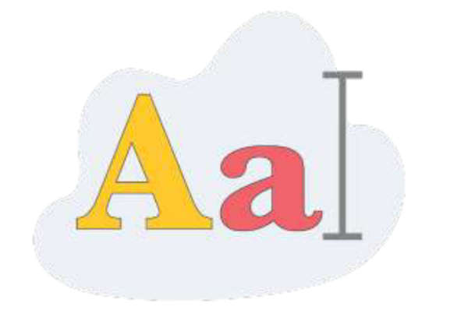


Image
Video
Text
Good Luck

Question B: write the correct name of each part.

10000 | 1111101 | 110010000 | 1011000
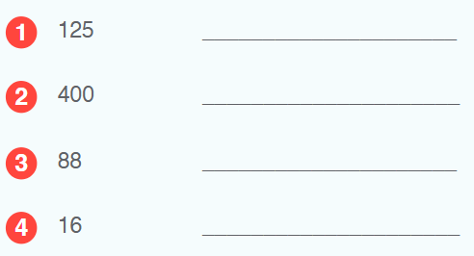
1111101
10000
1011000
110010000

Question C: write the correct name of each part.

110 | 219 | 255 | 136
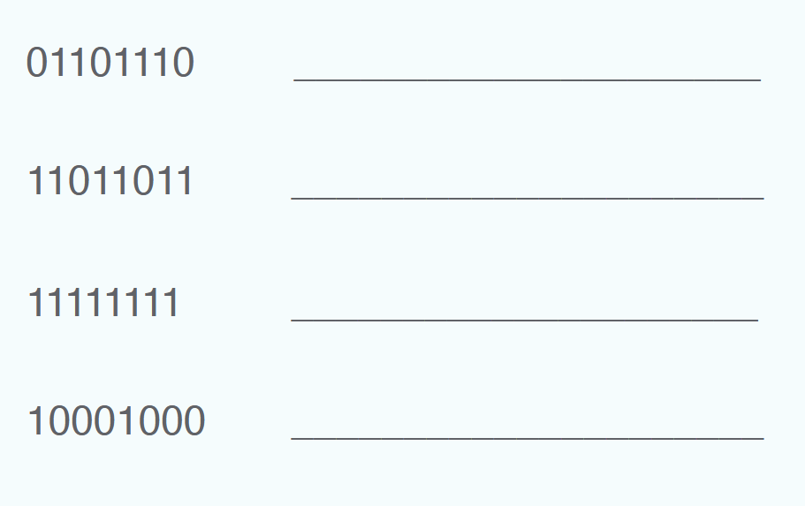
110
255
136
219

